react auto complete error in vs code

click on settings icon present in vs code left bottom side

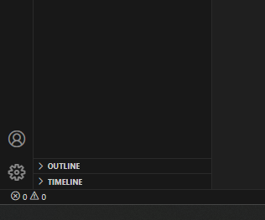

Click on Settings option

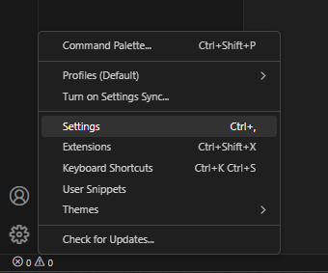

Click this icon

Open Settings ( JSON )

Present Top right

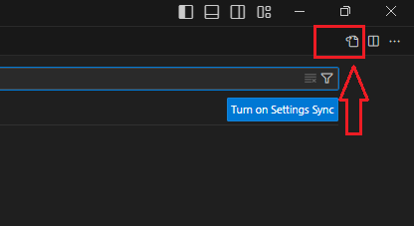

Add this code inside json

{

    "window.zoomLevel": -1,

    "emmet.includeLanguages": {

        "javascript": "javascriptreact"

    },

    "emmet.syntaxProfiles": {

        "javascript": "jsx"

    },

*// "workbench.startupEditor": "none",*

    "workbench.colorTheme": "One Dark Pro Monokai Darker"

}

Save and exit

Done